Arm-BCI Copilot — Progress Report
Optimizing the copilot’s training data

Overview
- Goal and setup. The model and control law are settled; the open lever is the training data. We ask which training-data configuration maximizes within-subject copilot accuracy, holding fixed the supervised LSTM, the corrective magnitude (0.01), the within-subject protocol, and evaluation on real EEGK data.
- Baseline (real data). A copilot trained on a subject’s own real data improves accuracy by +1.84 ± 0.30 pp over raw BCI (5 held-out splits) — the target any synthetic strategy must beat.
- Hypothesis tested so far — synthetic does not beat real. Neither EEGK sim nor the endpoint-modeled surrogate improves on the real baseline, alone or blended (the blend helps only 1 of 5 subjects). A diagnostic shows why the surrogate fails: it copies endpoint statistics but not the intent-to-path structure the copilot exploits.
- Open next step. A process-modeled surrogate — proposed, not yet built — is the untested candidate that could help sparse subjects by simulating the decoder’s error process rather than its endpoints.

1. Goal and fixed configuration
Goal. Find the training-data configuration that maximizes within-subject copilot accuracy on real EEGK data. Everything except the training data is held fixed:
- Model type: supervised LSTM copilot (DAgger training).
- Copilot corrective-velocity magnitude: 0.01 (the established near-optimum).
- Train/test protocol: within-subject — one model per subject, evaluated on that subject’s held-out real runs.
- Evaluation data: real EEGK data (held-out test runs, common to every configuration).
Pipeline note. The pipeline was rebuilt into a shared, leakage-audited framework (a single corrective-velocity controller; batched simulation ~120× faster). All results run from committed scripts; generated data is regenerable and excluded from version control.

2. Baseline — training on real EEGK data
The copilot trained on a subject’s own real data is the baseline every synthetic strategy must beat. Under the fixed protocol it improves accuracy by +1.84 ± 0.30 pp over raw BCI, stable across five held-out splits.
Per-subject (ordered by available real training data):
Subject | Train trials | Δ vs raw BCI
S05 | 1153 | +1.50
S02 | 1112 | +3.62
S01 | 477 | +1.11
S04 | 456 | +1.10
S07 | 265 | +0.18
The two subjects with the least real data (S04, S07) show the smallest gains — this is the sparse regime the synthetic-data hypothesis targets.

3. Hypothesis and synthetic data types
Hypothesis. Because real data is limited per subject, adding synthetic training data to the sparse real set may build a better copilot. Three synthetic sources are considered.
A. EEGK sim (tested). Trajectories from earlier sessions re-decoded through the current decoder — genuine human data, dense, same subject, but produced by a different decoder.
B. Surrogate, endpoint-modeled (tested). A per-subject synthetic set that measures, from real trajectories, the distributions of endpoint angular error, final radius, step magnitude, and per-tick wobble; it then draws a wobbly path from those statistics and rigidly rotates it so the final direction equals the target plus a sampled error. This reproduces the endpoint and step-size statistics but not the correctable trajectory structure the copilot relies on: because the wobble is target-independent and rigidly rotated onto the endpoint, a wrong-endpoint trial carries no trace of the true target. The in-distribution diagnostic confirms it — a copilot trained and evaluated on the same source:
Source (in-distribution) | BCI baseline | Copilot | Δ
S02 — real | 64.1% | 66.8% | +2.69
S02 — surrogate | 63.3% | 62.6% | -0.69
S05 — real | 66.2% | 67.0% | +0.72
S05 — surrogate | 64.2% | 65.1% | +0.97
On S02 the surrogate cannot beat its own baseline even in-distribution (−0.69) — there is nothing to learn — while real is clearly correctable (+2.69). Where the surrogate is correctable (S05, +0.97) the copilot is denoising synthetic wobble, which does not transfer to real.
C. Surrogate, process-modeled (proposed — not yet built). The fix implied by the diagnostic: instead of fixing a wrong endpoint and adding target-independent noise, simulate the decoder’s error process over time — start from the true target and corrupt the path with temporally-correlated, target-dependent noise — so that wrong-endpoint trials still carry recoverable intent, as real trials do. Building this faithfully may itself require non-trivial real data (a possible circularity), so whether it helps sparse subjects is an open research question.

4. Protocol and results
Protocol. For each subject, train copilots on blends of real + synthetic data (per synthetic type) and identify the blend that maximizes held-out accuracy. The spectrum runs from 100% real (the baseline) to 100% synthetic. Results below cover EEGK sim and the endpoint-modeled surrogate; the process-modeled surrogate is pending, and a full ratio sweep at fixed budget is future work (present results vary the real budget).
Pure synthetic (100% synthetic). Trained on synthetic alone, neither source beats real.
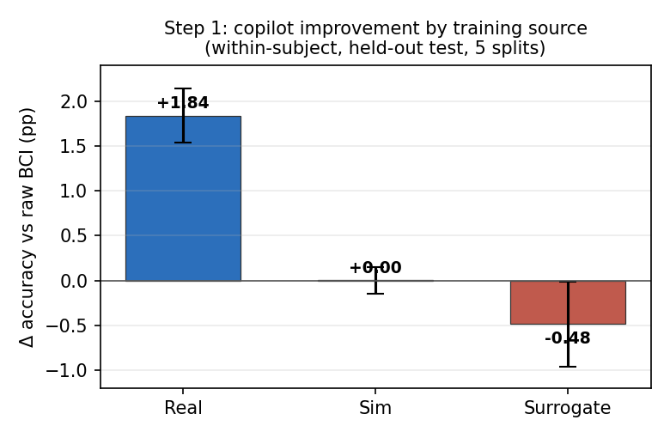
Figure 1. Copilot improvement over raw BCI by training source (mean ± std, 5 splits).
EEGK sim is break-even (+0.00 ± 0.15 pp) and the endpoint surrogate is slightly negative (−0.48 ± 0.47). The real-vs-sim comparison is the cleanest evidence — sim is genuine re-decoded human data, so real outperforming it isolates the value of distribution match with no generative-model assumption. Per subject:
Subject | Sim Δ | Surrogate Δ
S02 | -0.60 | +0.98
S05 | +1.38 | +0.42
S01 | -1.49 | -3.34
S04 | +2.20 | -3.94
S07 | -3.68 | +0.00
Blends (real + endpoint surrogate). Adding the surrogate to real, as the real budget is starved from full down to ~50 trials:
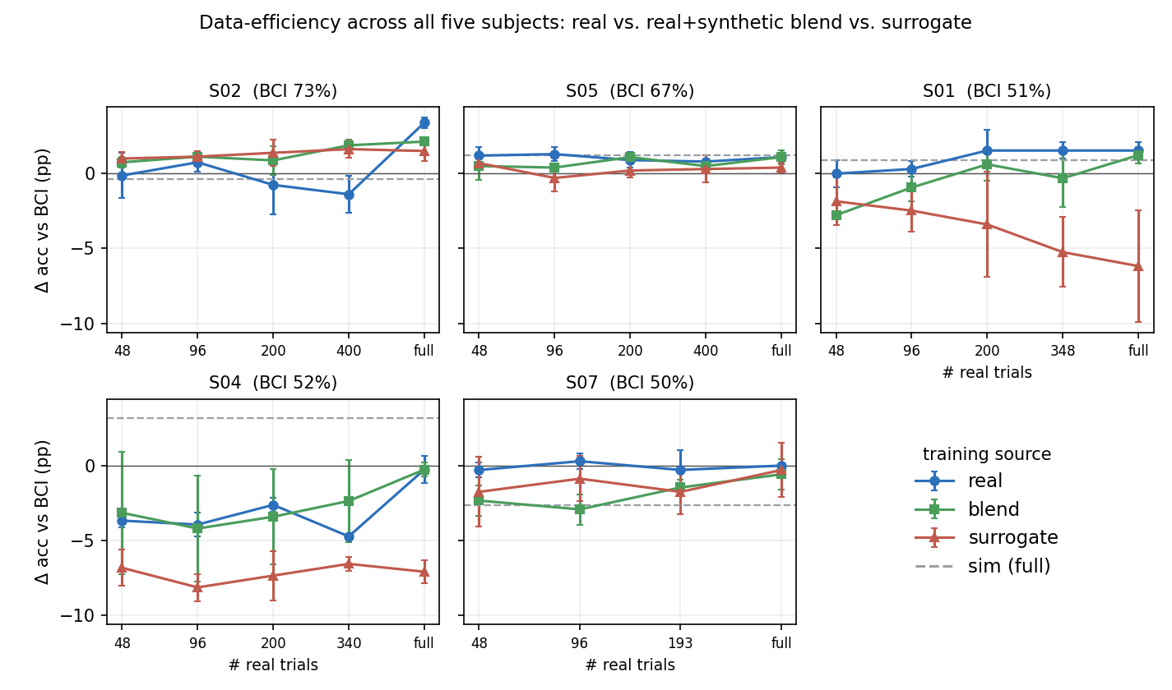
Figure 2. Copilot improvement vs. real training budget, all five subjects (mean ± std, 3 splits).
Summary (Δ pp vs raw BCI; sparse = ~50 real trials, full = all available):
Subject | Real (sparse) | Blend (sparse) | Real (full) | Blend (full) | Verdict
S02 | -0.13 | +0.75 | +3.40 | +2.14 | blend helps
S05 | +1.20 | +0.50 | +1.10 | +1.10 | real fine
S01 | +0.00 | -2.78 | +1.54 | +1.23 | blend hurts
S04 | -3.68 | -3.15 | -0.26 | -0.26 | none help
S07 | -0.29 | -2.34 | +0.00 | -0.58 | blend hurts
The blend beats real-alone in the sparse regime for S02 only; it is neutral on S05/S04 and harmful on S01 and S07. No blend reliably beats real. This bounds the endpoint surrogate (Section 3), not synthetic augmentation in general.

5. Status and next steps
Where this leaves the two questions. (1) Training on real alone is the best default — it wins or ties for four of five subjects, and the synthetic types tested do not beat it. (2) Most subjects reach their benefit with a few hundred real trials or fewer (S05 by ~50, S01 by ~200), so the calibration burden is modest; the tested synthetic data does not reduce it. Both answers are specific to the synthetic types tested so far.
- Build and test the process-modeled surrogate. This is the decisive experiment for the augmentation hypothesis — the endpoint surrogate’s failure does not settle it.
- Complete the blend-ratio sweep at fixed budget. Present results vary the real budget; a ratio sweep would map the full real–synthetic spectrum.
- Investigate S04. No training source yields a positive result there, suggesting uncorrectable trajectories or a subject-specific issue.

